

NAME – SUBASH G COURSE NAME –CLOUD COMPUTING

REG NO – 192572150 COURSE CODE – CSA1520

LAB EXPERIMENTS

Experiment no 1: create a simple cloud software application and provide it as a service using any cloud service provider to demonstrate software as a service (saas).
Implementation output :
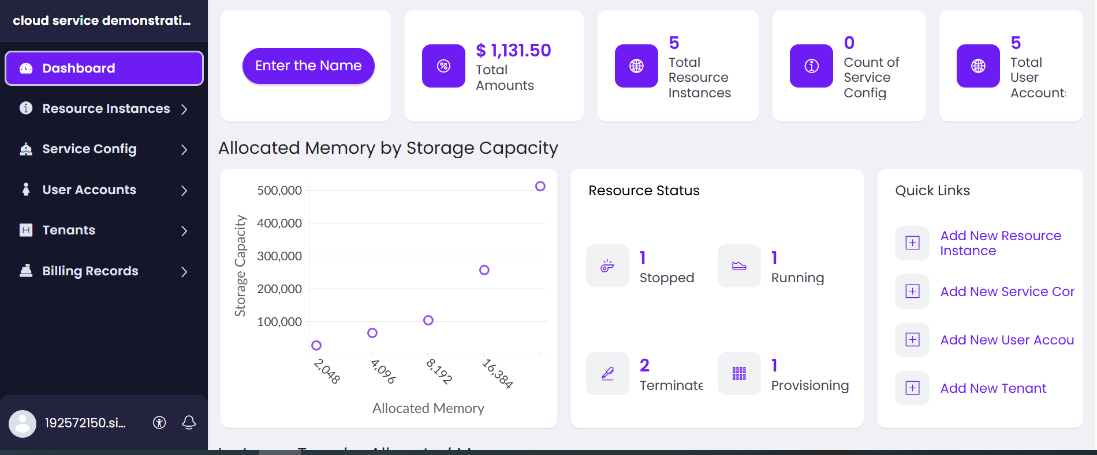

Experiment no 2: Create a simple cloud software application for Flight Reservation System using any Cloud Service Provider to demonstrate SaaS
Implementation output :
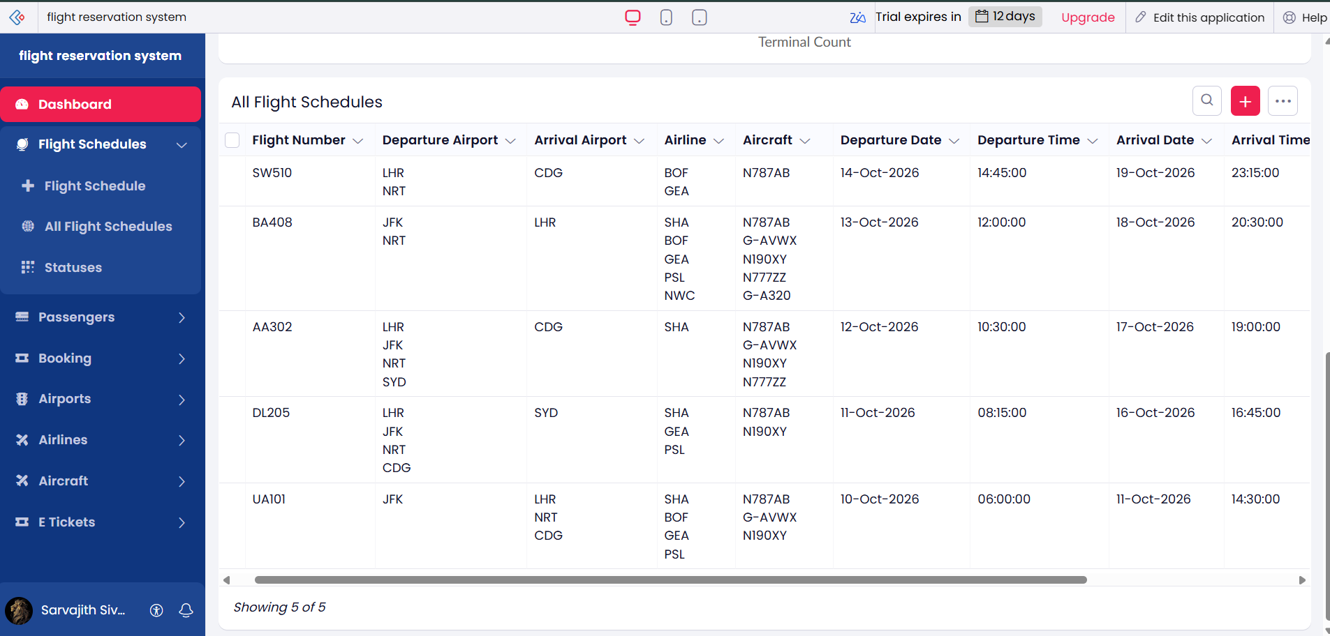

Experiment no 3: Create a simple cloud software application for Property Buying & Rental process (In Chennai city) using any Cloud Service Provider to demonstrate SaaS
Implementation output :

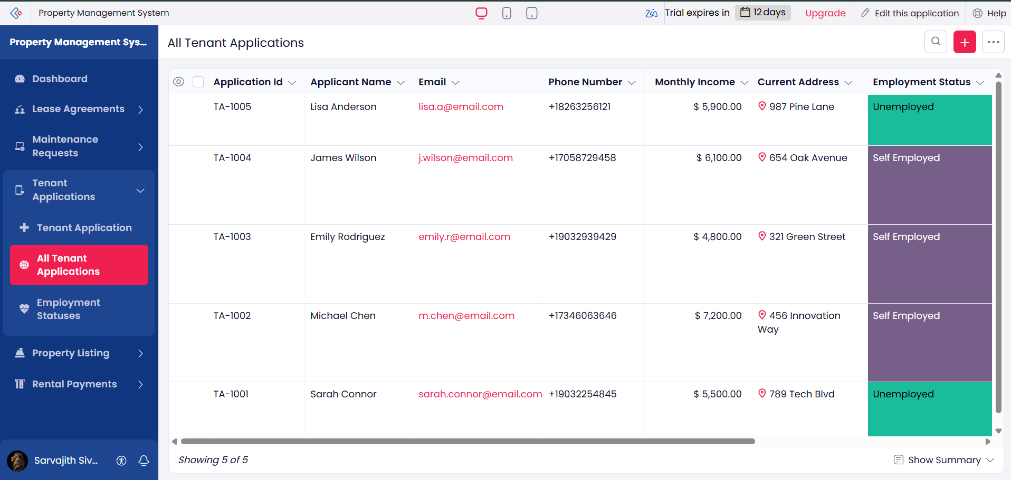

Experiment no 4: Create a simple cloud software application for Car Booking Reservation System using any Cloud Service Provider to demonstrate SaaS.
Implementation Output :
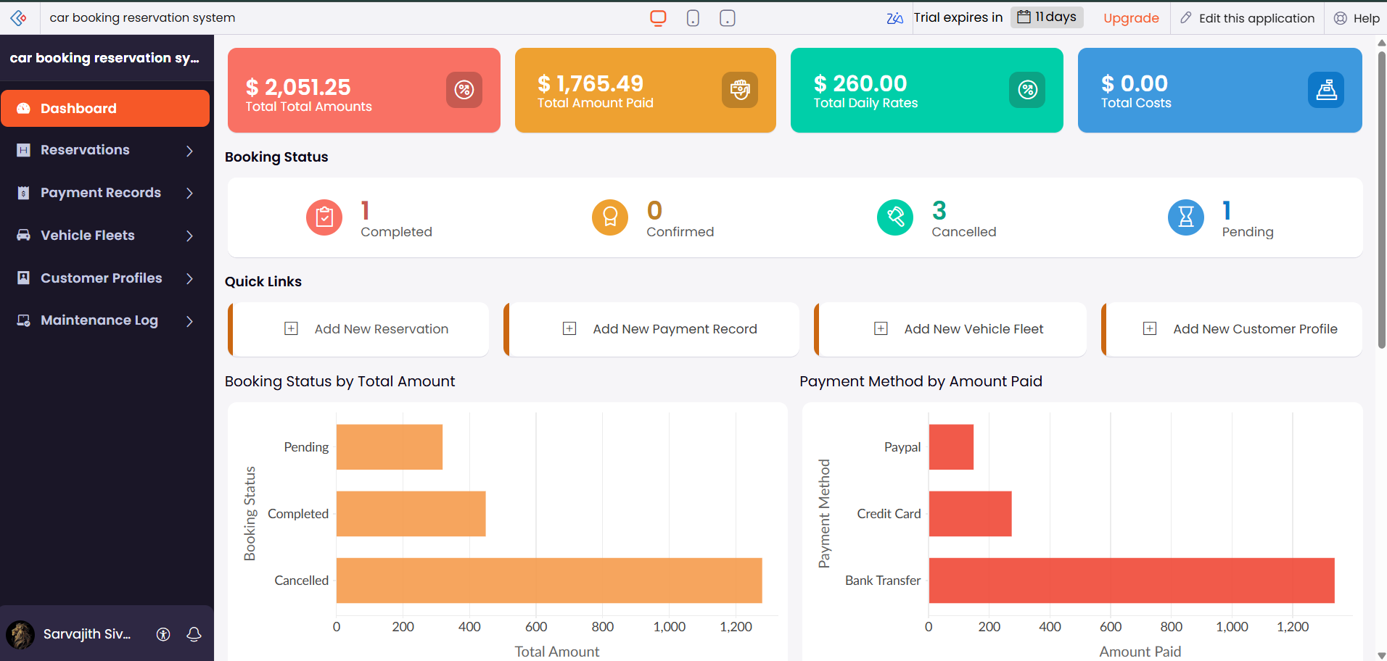

Experiment no 5: Create a simple cloud software application for Library book reservation system for SIMATS library using any Cloud Service Provider to demonstrate SaaS
Implementation Output :

